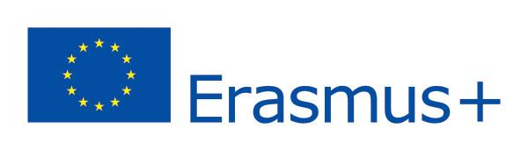
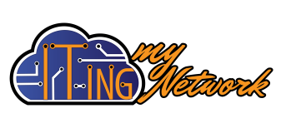
Changing lives. Opening minds.

ERASMUS PLUS:
Learning Mobility of Individuals, Mobility of learners
and staff, Youth mobility, EVS mobility
IT-ing my Network - 2016-3-RO01-KA105-035482
Training Course: 08 - 15 August 2017, Rm-Sarat, Romania
Participant form

First name |  | Last name
Full home address
Nationality
Date of birth |  | Place of birth
Gender
Mobile telephone (incl. international dial code)
E-mail
Level of English | ☐ Basics ☐ Intermediate ☐ Good ☐ Fluent  It is important for the organizers to be able to set the English level of the entire project group
Occupation
Name of the NGO you represent
Why did you decide to join this project?
When the project ends, how would you share what you’ve learned?
What do you expect, want to happen/discover during the project?
Fewer opportunities* | Check and detail the fewer opportunities that you are facing:  ☐ Social obstacles ☐ Economic obstacles ☐ Disability  ☐ Educational difficulties ☐ Cultural differences  ☐ Health problems  ☐ Geographical obstacles ☐ +Others-mention:
Emergency Contact Details: who should we contact in case of emergency?
(name, phone, language spoken)

*The disabilities are conditions that do not affect negatively your selection for the project. Our specific project aims at social inclusion; therefore we give priority to youngsters with fewer opportunities. What each participant declares in the form is taken for granted (not checked) and it’s kept confidential only for the organizers and the NA. Check the one(s) that represent you and give a short comment on it, if you please.You can find the detailed explanation below:
-Social obstacles: young people facing discrimination because of gender, ethnicity, religion, sexual orientation, disability, etc.; young people with limited social skills or anti-social or risky sexual behavior; young people in a precarious situation; (ex-)offenders, (ex-)drug or alcohol abusers; young and/or single parents; orphans; young people from broken families.
-Economic obstacles: young people with a low standard of living, low income, dependence on social welfare system; in long-term unemployment or poverty; young people who are homeless, young people in debt or with financial problems.
-Disability: young people with mental (intellectual, cognitive, learning), physical, sensory or other disabilities.
- Educational difficulties: young people with learning difficulties; early school-leavers and school dropouts; lower qualified persons; young people with poor school performance.
- Cultural differences: young immigrants or refugees or descendants from immigrant or refugee families; young people belonging to a national or ethnic minority; young people with linguistic adaptation and cultural inclusion problems.
- Health problems: young people with chronic health problems, severe illnesses or psychiatric conditions; young people with mental health problems.
- Geographical obstacles: young people from remote or rural areas; young people living on small islands or peripheral regions; young people from urban problem zones; young people from less serviced areas (limited public transport, poor facilities, abandoned villages).
Please return to contact@pel.mk this form dully filled and ‘saved as’ the name of the project!
Thank you for your application!

